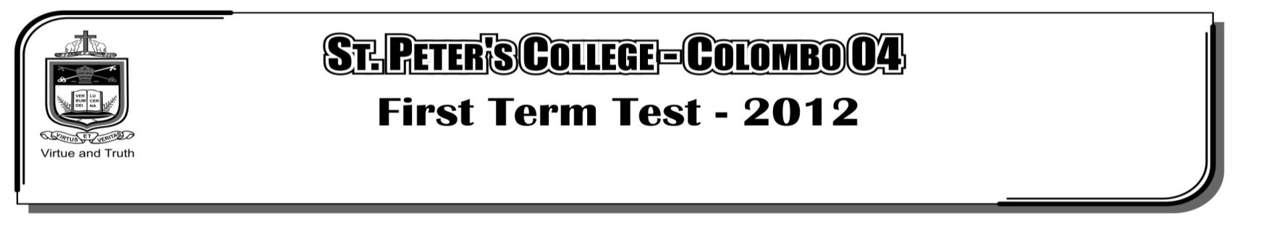

**SPECIAL EVALUATION (FIRST TERM) – 2022**

**Hours**

**GRADE 06 – western music**

Name: …………………………………..……… Class: …………….. No: …………

**Part** - **I**

* **Underline the correct answer.**

01. There are _________ lines in the stave,

i. 4 ii. 5 iii. 6 iv. 3

02. The four spaces in the Bass staff are,

i. F A C E ii. A C E G iii. E G B D iv. G B D F

03. The five lines in the Treble Clef,

i. E G B D F ii. G B D F A iii. A B C D E iv. F A C E G

04. Another name for Treble Clef is,

i. F clef ii. G clef iii. B clef iv. C clef

05. There are _________ spaces in the stave,

i. 3 ii. 4 iii. 5 iv. 6

06. The middle C note is written in the _________ of the great staff,

i. Centre ii. Top iii. Bottom iv. Side

07. The Bass Clef is also known as _________ clef,

i. G clef ii. F clef iii. A clef iv. B clef

08. The lyrics and music of our National Anthem was written by,

i. W. D. Amaradeva ii. Sunil Shantha

iii. Nanda Malini iv. Ananda Samarakoon

09. Letter names of the following notes are,

i. AB ii. CD iii. AF iv. CG

10. Music is made of,

i. Lines ii. Spaces iii. Sounds iv. Clef

* **Mark  or  .**

11. Birds are the nature’s best musicians. ( )

12. A wedding is a social function. ( )

13. You can walk or talk while the National Anthem is being played. ( )

**B**

**A**

* **Match each name with the correct sign**

|  |
| --- |
|  |
|  |
|  |
|  |

14. Rests

|  |
| --- |
|  |
|  |
|  |
|  |

15. Stave

|  |
| --- |
|  |
|  |
|  |
|  |

16. Clefs

|  |
| --- |
|  |
|  |
|  |
|  |

17. Notes

|  |
| --- |
|  |
|  |
|  |
|  |

18. Barline

|  |
| --- |
|  |
|  |
|  |
|  |

19. Double barline

|  |
| --- |
|  |
|  |
|  |
|  |

20. Time signature

***(20 Marks)***

**Part – II**

* **Compulsory Question**

01. Draw the keyboard name all the white keys. ***(Marks 05)***

|  |  |  |  |  |  |  |  |
| --- | --- | --- | --- | --- | --- | --- | --- |
|  |  |  |  |  |  |  |  |

Name the notes ***(Marks 05)***

|  |  |  |  |  |
| --- | --- | --- | --- | --- |
|  |  |  |  |  |
|  |  |  |  |  |
|  |  |  |  |  |
|  |  |  |  |  |

* **Select two questions**

02. Draw the correct clef to the given note Treble or Bass clef. ***(Marks 05)***

|  |  |  |  |  |
| --- | --- | --- | --- | --- |
|  |  |  |  |  |
|  |  |  |  |  |
|  |  |  |  |  |
|  |  |  |  |  |

B E A G D

Name three sounds heard at home. ***(Marks 03)***

1.

2.

3.

Name two sounds heard in the school. ***(Marks 02)***

1.

2.

03. Sound is created by nature, name 03 sounds of nature. Draw one picture. ***(Marks 05)***

1.

2.

3.

Sound is created by man. Name 03 man - made sound. Draw one picture. ***(Marks 05)***

1.

2.

3.

04. Write the first verse of the College Anthem. ***(Marks 04)***

Write four lines of a Children song (English song). ***(Marks 03)***

Write four lines of the National Anthem in Sinhala or English. ***(Marks 03)***